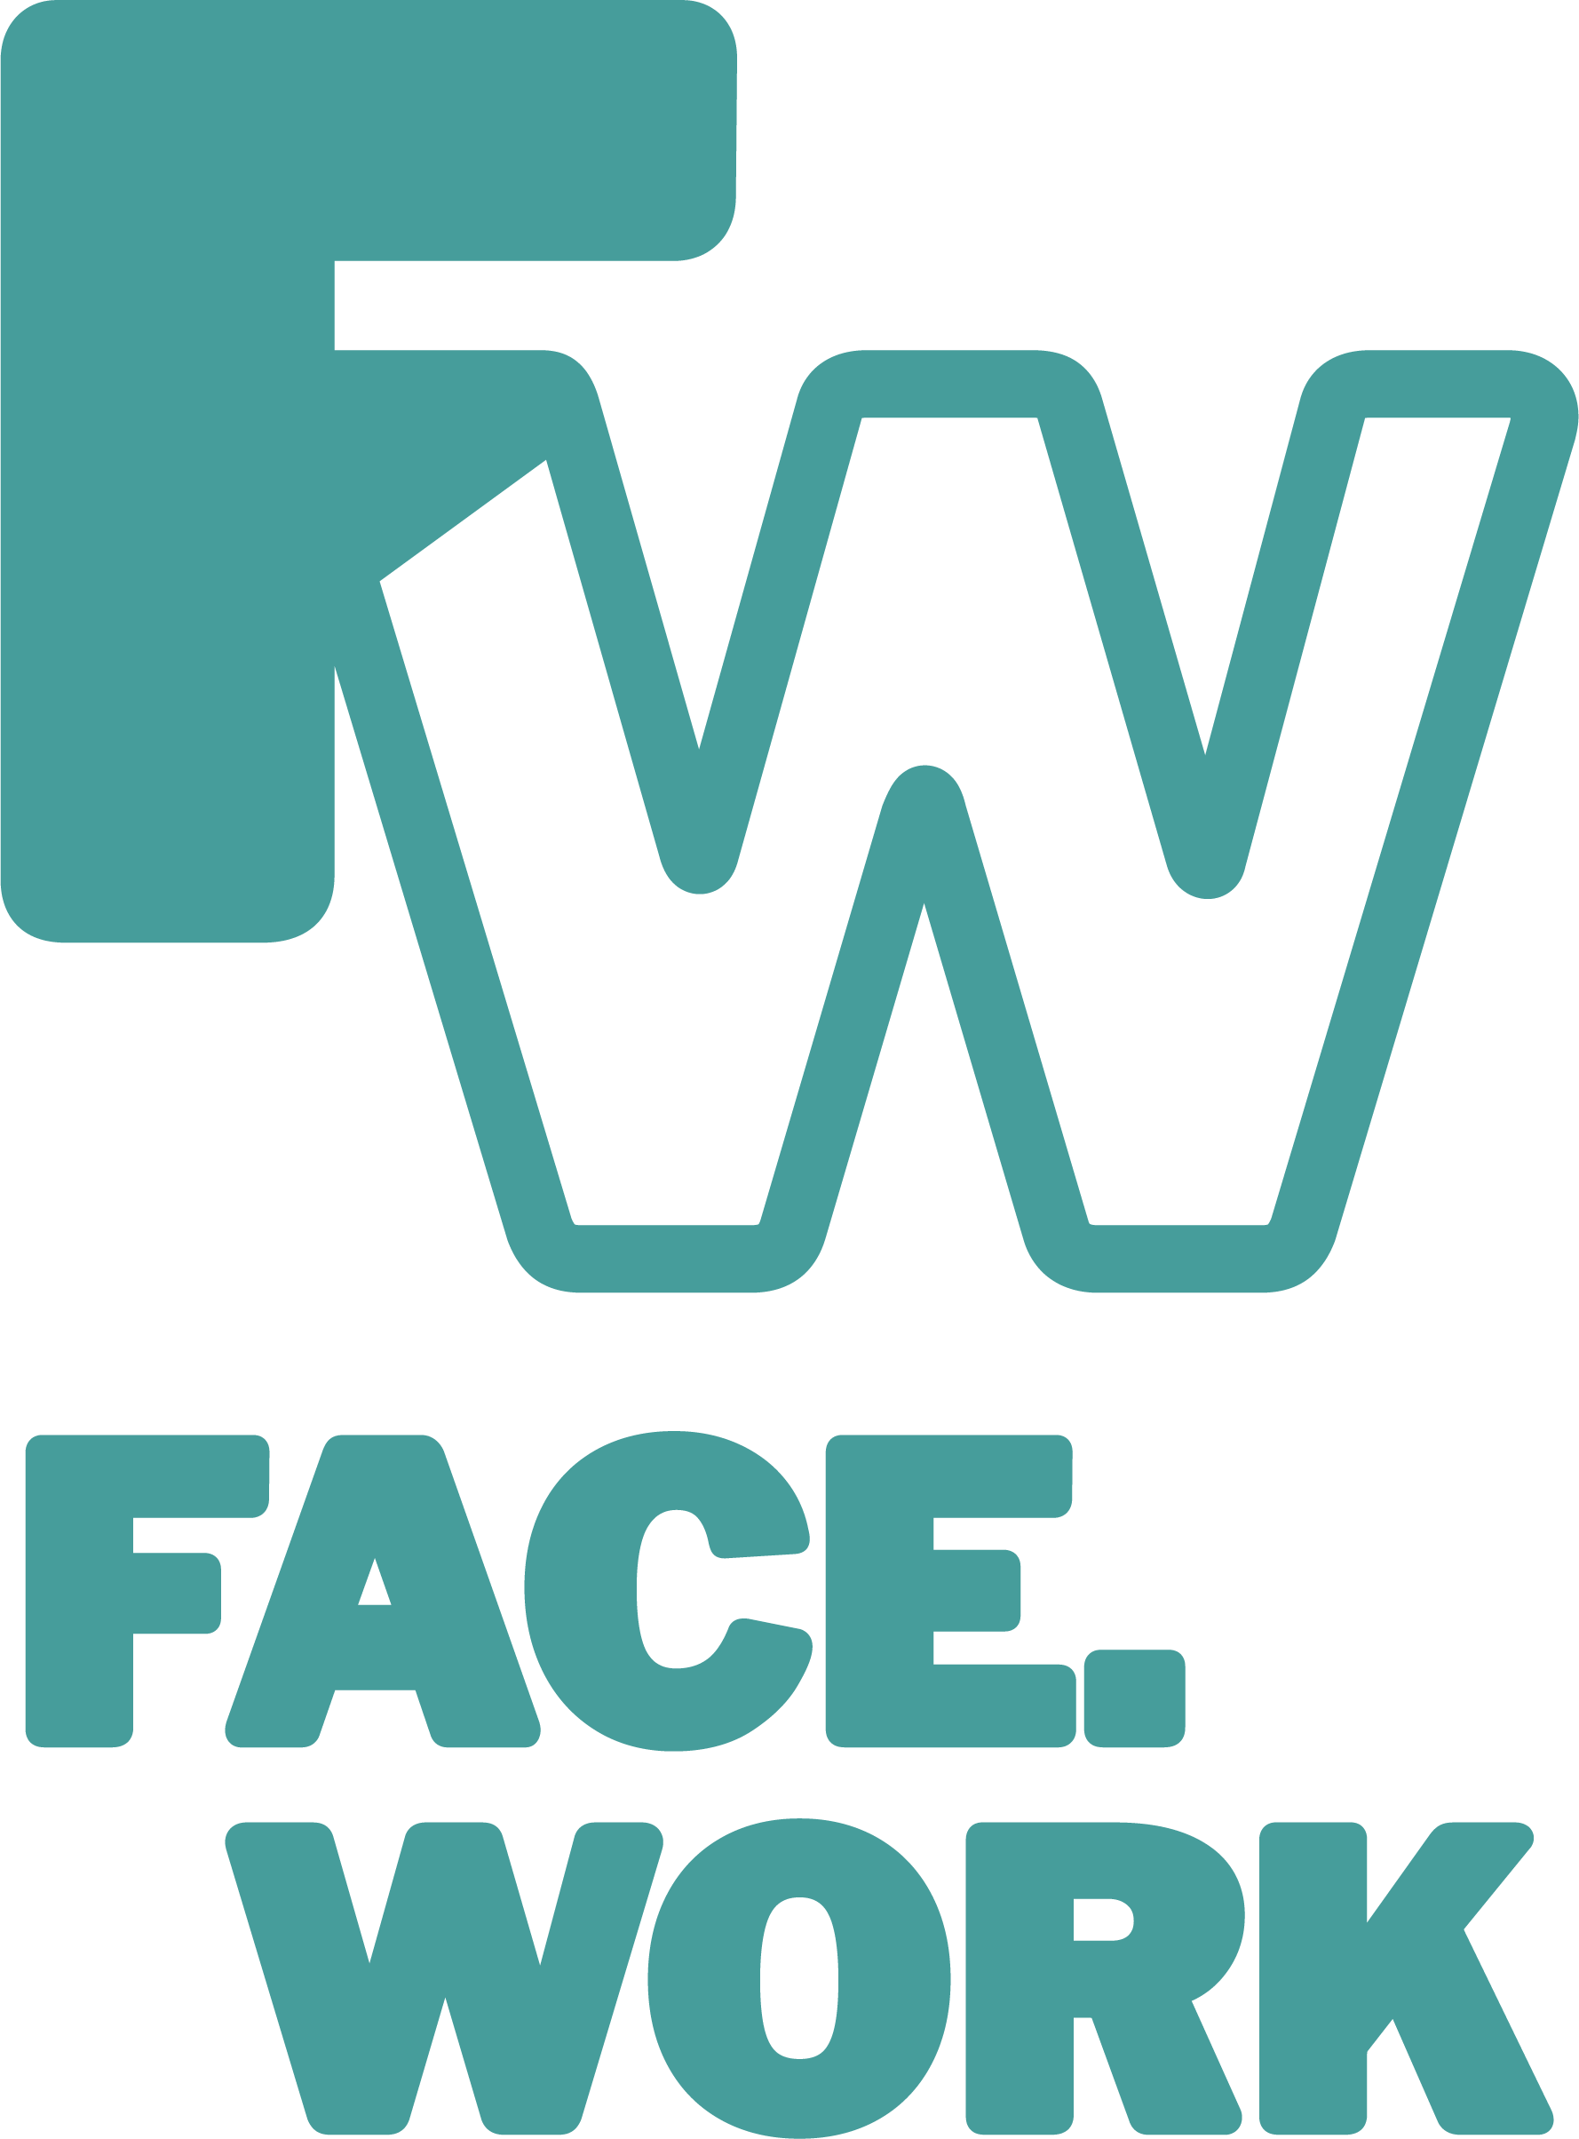
What is The Facework Group CIC?
www.face.work

Develop your skills. Expand your mind. Grow with the people around you.

WHAT IS FACEWORK ?

The Facework Group is a Community Interest Company that equips people to face the changing world of work through skills training and by developing affordable workspaces where communities can learn, share and work together. We are passionate about supporting young people to become leaders who can then teach and inspire their peers. As a social enterprise we plough all our profits back into the work and are committed to social impact.

OUR VISION:

Facework empowers young people to thrive in a changing world of work.

By ‘work’, we mean any meaningful activity that provides an individual with an active purpose and that enables that individual to earn a living as a result. This may mean ‘employment’ in the traditional sense – being employed by someone else on a full-time basis; or it may mean self-employment; it may encompass a portfolio approach, where working/learning/volunteering/etc are blended; and it may mean work that is socially driven. Above all we want to help young people to find work and training opportunities which match their skills, their character, values and potential.

OUR MISSION:

We fulfil our vision and help empower young people to thrive through the following:

- We help young people understand and navigate the world of work, giving them a sense of the opportunities that are there and the many pathways that are open to them.
- We support young people develop their self-awareness, their confidence and their capacity to make informed decisions about what they want to do as they transition from education to work.
- We co-design programmes which give young people the opportunity to build their skills, develop their network and engage in experiences that act as a launchpad for what they might do next.
- We invite young people to become active Agents of Change and support their peers in the journey through co-design of new youth-driven resources, Facework Chapters and supporting their peers.

ACHIEVING OUR OBJECTIVES:

We achieve our objectives and bring about personal development through a number of channels, that include, but are not limited to the following:

- Providing young people with a place/space to connect, share and learn. This includes establishing formal community workspaces but also pop-up spaces, and online platforms.
- Offer young people skills training to help them develop their employability. This is focused on helping youth identify what they are already good at and play to their strengths as well as hosting training around an industry theme.
- Work with young people to co-design and create their own careers and employability training resources, which are quality assured but radical in their approach.
- Expose young people to near peers, employers and others with experience of working life. This includes advocating for young people and closing the gap between education and employment and supporting employers to be more engaged with training and empowering youth.
- Create opportunities for young people to work – and learn through working – either by volunteering or through paid activities. This includes actively brokering work opportunities for young people and identifying short ‘gig’ tasks which help build confidence and experience
- Help young people to build their professional network This includes linking them with other Faceworkers, providing certification for courses they have completed, arranging conferences and events which promote networking and sharing.

FACEWORK PROJECTS
At this stage, possible Facework projects that align to the vision and objectives set out in this paper include:

- The design and expansion of the Facework’s model which involves training young people to run regular network-building meetups to deliver training and support peer-to-peer connections
- The delivery of individual training experiences based on the STEPS resources.
- The provision of coaching and mentoring, connecting young people to those who are able to offer this (which could be experienced workers/employers or close peers).
- The running of sector-specific career discussion sessions where those with experience of working in a particular sector share their experiences.
- The utilisation of technology including innovating in using emerging mobile apps, social media channels and AI to find new ways to empower young people to thrive in work.
- The establishment of a Gig Exchange where young people undertake short-term employment ‘gigs’ with local workers/employers for payment and experience.
- The expansion of our affordable community workspaces both in the UK and abroad.
- The development of our consultancy services providing advice and support for new ventures both in terms of community workspaces but also in the design of youth employability training programmes.

OUR APPROACH TO LEARNING AND PERSONAL DEVELOPMENT

This is underpinned by the following 6 principles:

- We learn best through real-world, active experiences and become better informed through listening to – and interacting with – others.
- We learn best through collaborating which helps us become motivated to and engaged in learning.
- We learn best when we consolidate our knowledge and find ways to bring learning to life for others. Teach Once; Learn Twice.
- We learn best when we make better decisions, when we are better informed and through creating, and taking ownership of our own learning experiences.
- We learn best when we get feedback and see the impact of our learning as real, embedded change, not with a meaningless certificates.
- We learn through being connected outside of our ‘silos’. This includes utilising mobile technology to collaborate with others and explore opportunities to work across borders, in different languages, cultures, and economies.

OUR VALUES

Everyone is a learner
We want to treat young people not as consumers of training programmes, but content creators and agents of change. By training young people to lead in the design and delivery of employability training and enterprise 'hubs,' we help them create authentic and impactful resources and become advocates for their peers. We want at all times to value and prioritise reciprocal learning and sharing.

Respect for each other
In all we do we want to respect what individuals bring to the learning. This includes ensuring that localised programmed are that – truly local and not imposed from afar. If we have the opportunity of replicating our work abroad we will ensure that the work is driven and led from those best placed to know what will work and what can have the greatest impact.

Authenticity and Honesty
We know that there are lots of employability programmes and schemes of work. We want to learn from these but equally believe that ‘one size does not fit all’ and therefore want to ensure that the resources we produce are built on authentic experiences and are shaped by the local need and experience.

Committed to quality
We believe ‘Excellence attracts attention’ and want to ensure that everything we produce or run is of the highest quality. As an organisation which is public facing (retail) as well as strategic (wholesale) we want to have the highest levels of customer care and working in close partnerships. To that end we will evaluate our impact and learn from our mistakes.

Innovation
We believe that careers guidance and programmes of employability training are not well funded or prioritised. We want to all the time ask what radical intervention will make a difference? What innovation can we harness to make a real difference. To that end we will embrace new online learning and mobile resources to expand our capacity and influence and reach wider audiences.

HOW WE WILL KNOW WHEN WE HAVE BEEN SUCCESSFUL?

Facework will also become an incubator for projects both in the UK and elsewhere that achieve our objectives, piloting approaches and sharing learning between all Facework actors and others operating in this space. Where possible, we will supervise these projects into being but then hand over management control to young people as much – and as early – as possible.

We are committed to quality measurements of our impact to ensure we are achieving our objectives and as a mechanism to support our funding applications. Impact measurements include :

- Number of young people experiencing a Facework intervention
- Number of young people trained in the running of a Facework Chapter and number of attendees.
- Number of young people involved in ‘work experiences’ (interventions such as the gig exchange).
- Number of resources produced or shaped by young people – including IGTV broadcasts, STEPS Challenges, videos and advice to other youth.
- Number of employers/entrepreneurs/business people giving their time to support Facework
- Qualitative (measured) change in the confidence, competency and employability of young people experiencing a Facework intervention (including the production of detailed case studies).
- Number of young people undertaking meaningful work (employed/self-employed/volunteering) post-Facework interventions That we can at least partly attribute to our input.
- Number of people accessing our online and offline centres and the transition to active membership and supporting others.

Last updated/reviewed October 2023

The Facework Group CIC (Community Interest Company) is registered in the UK company number 12598896 we run Hatcham House and Hatch Peckham.

