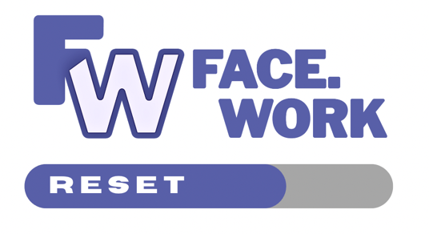
The Facework Group is a social enterprise that equips refugees to
face the changing world of work through employability and skills training. Each employability programme is 10 weeks long.

To date Facework has delivered 12 programmes to over 200 refugees in Lewisham borough. Our award-winning programmes have been recognised by the Mayor of London. (See letter here)

THE FACEWORK RESET PROGRAMME

Facework has won a ‘No Wrong Door’ grant from the GLA to train and equip refugees to replicate, manage and deliver Faceworks existing employability programmes into a borough's local refugee community. Each RESET programme is 3 months in duration.

EACH REFUGEE TO BE TRAINED IS:
- Nominated by a partnering borough from within their own refugee community and enrolled into a paid 300 hour placement with Facework. (Paid by the LA).
- Equipped and skilled by Facework to set up, manage and deliver Facework's bespoke, co-designed employability training programmes.
- Supervised and mentored by Facework on a continuous basis.

WHAT ARE WE LOOKING FOR?
We are looking for Local Authority partners to sponsor and join Facework’s RESET train the trainer programme. We are accepting only three London Authorities into each 12 week RESET programme to ensure quality delivery, starting January 2025. Each LA can nominate 2 refugees to RESET.

WHAT’S INVOLVED?
The candidate will be trained, accredited and equipped with the right skills and have completed:
- A thorough understanding of tools, techniques and best practice to manage and deliver the programme
- Adapting and translating the curriculum into their native language and local context.
- A co-designed Facework 10 week employability training programme, ready for delivery
- Secured relationships with key local organisations back in the partnering borough
- Active engagement in the partnering borough with:
  - Local volunteers
  - Key partnerships with potential work placement organisations
  - Programme contributors, successfully employed from within the refugee communities
- Thorough understanding of key elements, including:
  - Stakeholder and partner requirements
  - Reporting, documenting, guidelines and policies
  - Governance, safety and confidentiality related issues
- Marketing and Design Skills / promotional material to be designed
- Accreditation​​​​​​​

FOR MORE INFORMATION CONTACT Matt Breakwell - matt@face.work

