Confidential – not for circulation

Proposal for a Community ‘Hatch Maker’ space
in the old Post Office, New Cross Gate
Community Consultation
September 2021

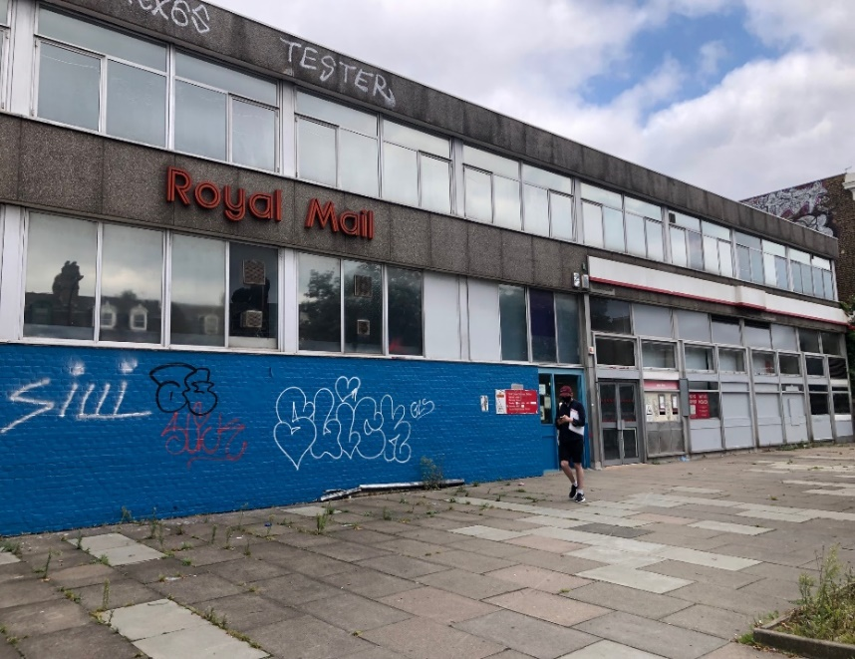
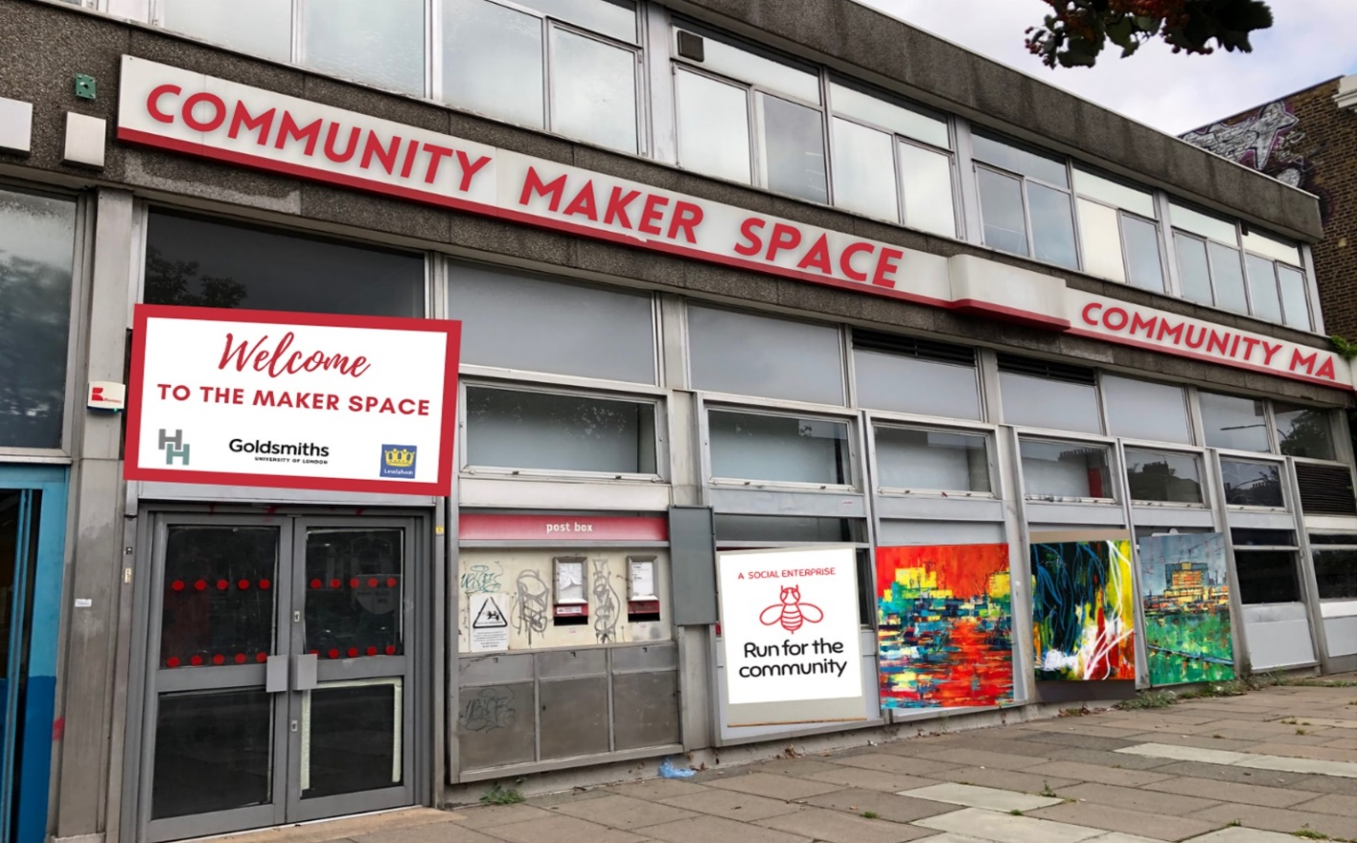
The un-occupied Post office next to the Royal Mail sorting office in New Cross as it is now.
And our vision (right) to transform this into a unique community ‘Hatch’ maker space.
A place to hatch new ideas, businesses, climate solutions and positive social impact in Hatcham South London. See www.hatchamhouse.com/makerspace

INTRODUCTION
This document outlines the opportunity for creating a unique ‘Maker’ space for local creatives and self-employed people living in the New Cross area from the current Post Office building. The proposal would be for permission from the Post Office to use the space on a ‘meanwhile’ 2-year basis starting in January 2022. This date coincides with Lewisham’s London Borough of Culture, an ambitious, year-long programme of events which celebrates local neighbourhoods, communities, and artistic endeavours.
The project would be run by Facework Group CIC (a social enterprise) which currently runs the successful Hatcham House community workspace close by. However, the project would be supported through a partnership with Lewisham Council, and The Creative Enterprise Zone and Goldsmiths University See final page for statements of support from these partners.
In summary, we believe that this pilot affords an exciting opportunity to develop a partnership and ensure a win/win for both the Post Office (and its social purpose agenda), local people, and the wider community. The meanwhile use would protect the building from being further vandalised, create real social value and potentially pilot a new shared-income, shared-use model which could ensure the viability of the space in the long-term. It is also an excellent way for the Post Office Group to demonstrate their corporate social responsibility, develop a new business model for their wider portfolio of disused Post Offices and build a good reputation among local people who would support this development and value the social usage of a building which many people felt sad was closing.

HISTORY
In January 2017 the New Cross Post Office was closed. Despite a campaign by local residents, local councillors and local businesses the site was closed and it has been vacant five years !
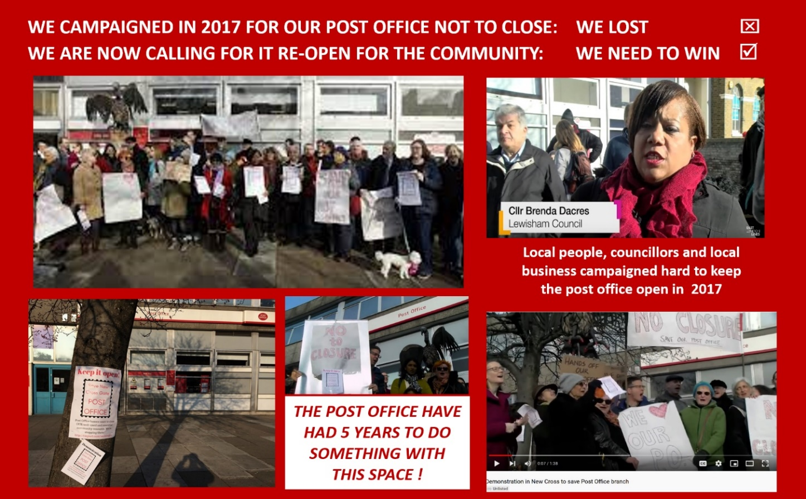
See campaign and short film at https://www.eastlondonlines.co.uk/2017/11/citizens-furious-closure-new-cross-gate-post-office/
Whilst we recognises that the Post Office is under enormous pressure and its business model is changing in line with changes in sending mail and accessing face to face services. However, we like many others - would maintain that as a vital part of our civic life, high street and sense of community. Like other large organisations it is recognizing that it can’t simply “DO” something with its local business without proper consultation, engagement and support from its customers, local residents and stakeholders in the area.
Indeed this site has become a terrible symbol of the failure of our high-street, and along with the closure of the bank, the local pub, the pharmacy and other long-term local traders, this stretch of our community is a travesty, especially when it is estimated that 10,000 passengers go past this site every day. Is this really what we want people to think of when they think of Lewisham, our community and the Post office ?
We believe in a post-covid world, we as people have a right to have more influence in the way our built environment is shaped (or not shaped in this case!). We have a vision for re-purposing this site, re-using it as a community work hub and place where communities can grow, become more resilient and get back into work. We also believe that as a site on the most polluted road in Lewisham we have a moral responsibility to green this site, and make this a climate positive project helping to educate, and co-design local solutions to the climate crisis.
IF NOT US -LOCAL RESIDENTS - WHO? IF NOT NOW, WHEN ?
We have the promise of funding, we have the experience and vision and if this site is left empty for another 5 years it will be a scandal.

WHY THIS PROJECT?
This project provides an exciting opportunity for a currently dis-used and prominent local asset to be brought back into a beneficial meanwhile use, managed and anchored by a well-respected CIC with experience of managing other local workspaces partnering with key local institutions and networks, including LB Lewisham, and the Creative Enterprise Zone, Goldsmiths College and local creative industries and artists.
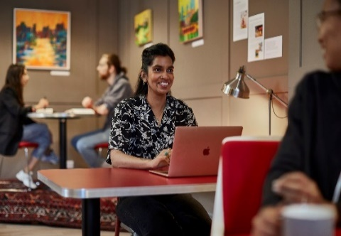
Covid has shown us that those who have work need much greater freedom and flexibility on where and how they work. But those who have been made redundat through Covid – largely young people, who have been disproprtionaly hit hardest, - now need support in becoming more enterprenurial in finding work or starting their own business.
Taking advantages of the huge shifts within technology and new tools which are giving people new opportunities to create products and services, we believe that creating a space for artists not just to create art, but create products to sell and create a business is vital. What learners need are the tools, space, up-skilling training, business development support, mentoring and a local peer network.
Buidling on the success of the Hatcham House workspace we are proposing to run a 2 year pilot in the Post Office creating a distinctive ‘maker space’ This would be a place to create, to learn, to mentor, to invent: a place for learning and innovation. It would also be a beacon for combatting the appalling levels of car pollution and air quality in the area.
We believe that a HATCH MAKER space combines the best in new models of education (learning by doing), enterprise (giving people an opportunity to create prototypes and get feedback) and community learning (just look at the impact that ‘The Repair Shop’ has had on the public with its tie in with recycle, reuse, reduce agenda). The illustration below captures the essence of what a maker space or Fablab is.
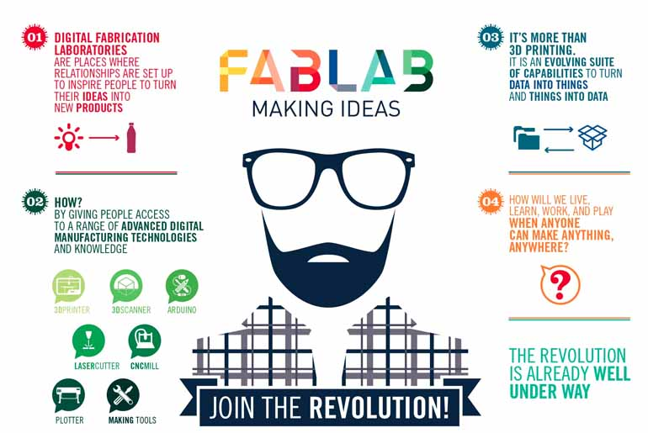

MAKER = CREATOR_= SHARING+ CHANGING

THE MAKER SPACE PILOT WOULD:
- Enable us to identify and partner with individuals/organisations with experience in providing tailored and focused business support and growth programmes and services for creative industries accessible to members of this workspace (i.e., business plan writing, accounting for small businesses, taking a concept to market, marketing etc). This would include the 180 current HH members but also local artists, makers and technicians.

- Be operated by Facework staff would managing the bookings and use of the space through the professional HH booking app. This currently links over 180 members to book and pay for use of the HH space daily. We would keep the usage for the Post Office to the same low daily charge so that from day one it is affordable and sustainable.

- Operate during the day staffed by one manager and volunteers. Minor ammendments to the secruity of the building and any temporary partitioning costs would be met by us and only undertaken following written permission and contractuarl agreement. -We would involve local decorators, young people and landscape designers to re-imagine the outside space.

- The space would operate on purely on a membership basis, thereby ensuring that we had control of who was coming in and out and ensuring safeguarding. If agreed with licensing we would be able to operate a limited bar service as we already have a personal license to sell alcohol at HH. However this would operate on a restricted evening useage only and be accessible to members using the space and for those attending well-run exhibitions, training sessions, events and local celebrations – this would not be available for private hire but we would help local people curate community social events and showcase emerging artists (music,digital, theatre, film, craftmaking, repairing you name it we would love to promote it!)
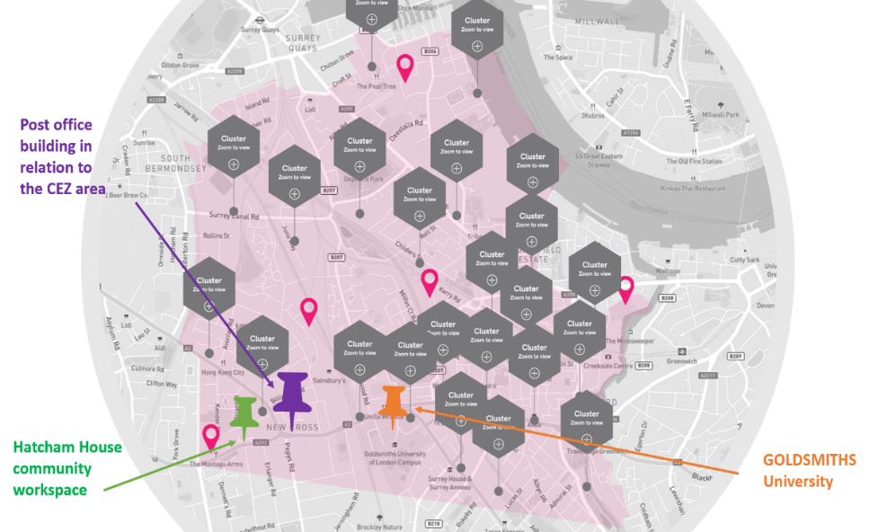
- The building would serve as a high-profile ‘GATEWAY’ to the Creative Enterprise Zone area (see map) and help put Lewisham’s creative sector on the map.
- We would make concession places for local young people, including those from Goldsmiths college who want to work alongside local artists and makers. We would also create 2 apprenticeship jobs and internships so that local people get a chance to learn and earn!

- Hatcham House already offers 10 spaces for CEZ members at HH but this new space would be better for creatives who need a different environment.

- A clearly drawn up legal document would be produced outlinig the relationships, responsiblities and exit strategy for the pilot. The governance of the project is crucial to get right but the partnershi of a non-commercial community interest company, suppoted by the Local Authority and linked to the CEZ and possibly Goldsmiths network is a good foundation for a professionally run programme.

- Facework would be responsible for the security and management of the space and ensure that the building was left in exactly the same way after the pilot. All costs of minor adaptations and running costs would be undertaken by Facework who would also pay a affordable rent for the use of the space.

Timeline

---- Borough of Culture period ---- Blocks below shown in quarters
2022  Q 1 | 2022  Q2 | 2022  Q3 | 2022  Q4 | 2022  REVIEW | 2023  Q1 | 2023  Q2 | 2023  Q3 | 2023  Q4 | 2024
Prepartory work  INCLUDES: | Opening 1st April 2022 | First programmes start | Summer square events | Are we building a sustainable funding model and real social traansformation? | Growth businesses and projects supported | Events and growth of programme | Evaluation of project and options for next stage ? | Transition to new site? | Possible new usage for building

- Secure agreement with Royal Mail Group (decision in principle by 1st December 2021) and confirm a contract for 2 year meanwhile use and partnership agreements for 1st April 2022
- Confirm partnerships with CEZ, LB of Lewisham, Goldsmiths and other potential funders.
- Complete funding bids for NCIL (£113K) and start a crowdfunder for social impact work
- Recruit a researcher to design an evaluation and impact assessment tool (before and after) what is the measurements of success. What are we innovating, making it sustainble? etc.
- Run a Christmas light up the square and design new murals for the area. (CEZ Creative Happenings funding applied for - £5K) - good opportunity for local consultation and ‘ownership’
- Securing a new Temporary Change of Use planning permission with Lewisham.
- Making sure that Lewisham HIGHWAYS dept provide all advice, and sign-off on all prosepective changes to the outside pavement space including health and safety, secrurty and greening.
- Explore a range of options for contract for occupancy and management of the space, including the potential for Facework to enter into a Management Agreement with the key funding partners.
- Preparation and minor modification of the Post Office space, and transformation of outside square
- Completion of all compliance (H&S) safeguarding, licensing, management agreements etc.
If we hadn’t already developed a track record of running a sucessful community workspace – Hatcham House, and established and maintained good partnerships, we would not feel confident in embarking on this higher-profile, larger programme. However we can work together – most importantly -with the community!

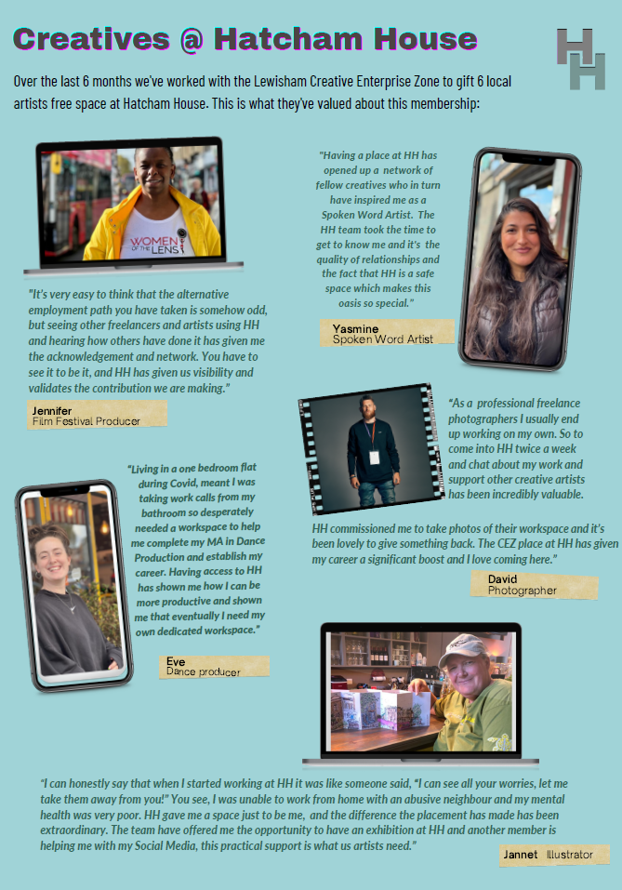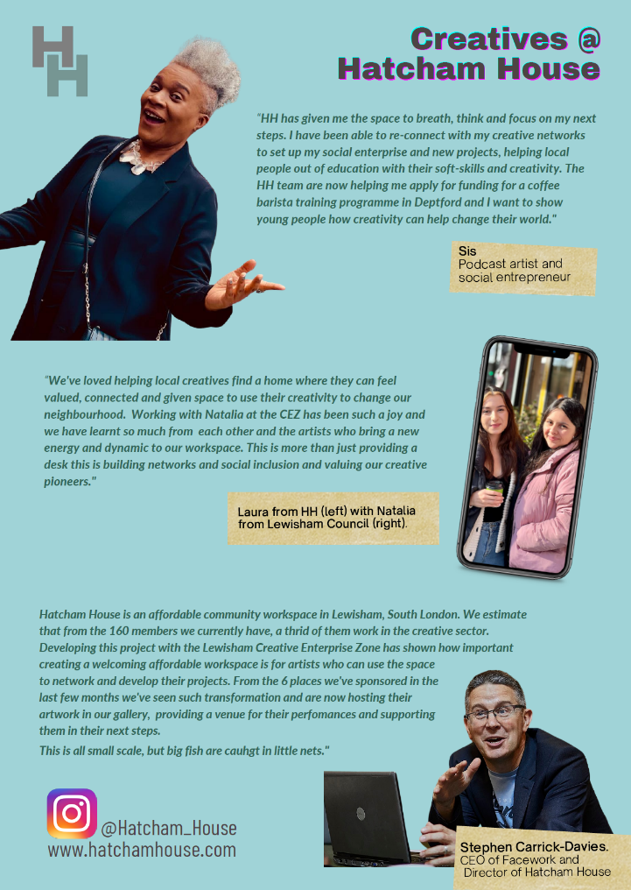

OUTCOMES OF THE PROJECT

We see this project having 3 clear important outcomes for at least 3 separate audiences:

LOCAL RESIDENTS |  | POST OFFICE GROUP |  | LOCAL COMMUNITY
- Affordable creative workspace  - Development of a network  - A space to ‘Hatch’ new businesses  - Accessible link with Goldsmiths’  - Space to use for exhibitions  - Pride in their area with new businesses start-ups and economic growth |  | - Opportunity to partner with trusted local players  - Keep the POST OFFICE site safe from squatters/graffiti  - Clear Corporate Social Responsibility example with excellent PR opportunities.  - Model for other sites and innovation. |  | - Improves footfall on highstreet  - Sign of economic renewal  - Builds profile of CEZ  - Keeps artists in the area (inc Goldsmiths’ alumni)  - Shows innovation  - Provides jobs  - Youth engagement  - We make this fun and engaging
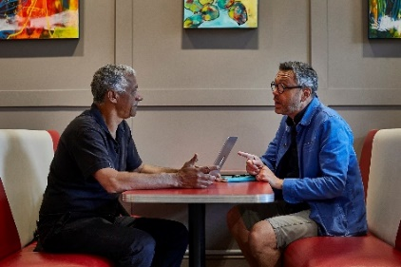  Two of over 180 local residents who are members of HH |  | 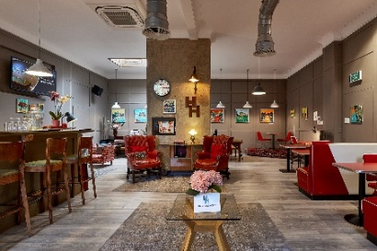Hatcham House building which Facework has improved and maintained to a high standard |  | 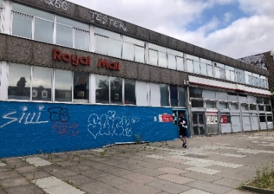  The Post Office building constantly graffitied and next to 3 business which are closed. (White Hart pub, bank, pharmacy)

OUTLINE COSTINGS

If The Post Office Group was to support this proposal in principle, we would establish a clear detailed budget for the 2 year pilot. This would include the following:

Amount paid in rental each month to Post Office
This would have to be on an pepper corn rental basis for 2 year period but guaranteed and paid in advance for each quarter.

Costs for adapting the inside of the space
This would be minimal – and capped at £15K which would include re-decoration, temporary desks, H&S requirements, signage etc. We would pay for this ourselves and make sure that all work complies to disability legislation requirements, H&S and local work-force involvement.

Running costs
We would want to secure a grant to cover the minimum running costs for the first year including a manager post plus contribution to core costs, overheads, insurances etc,. The aim would be to then run the programem on a self-sustaining model in the second year. Any budget will show what the projected income will be for the project, including Membership fees, usage for events/training and grants. We already run licensesd activities and can secure income from ticket prices, sales from licensed bar, merchandise and also – individual makers sales of their new products !

Evaluation and monitoring
We would want to build into the programme a research element. Working with ‘Art for regeneration’
(one of the HH existing members) we would want to create a report showing the impact and measurement criteria for impact in both the quantititive impact (numbers of people reached) but also the qualititive outcomes such as number of businesses started/supported.

Training and acivities budget
We would want to work with members of the space and local artists to host exhibitions and training events as well as have a more public facing ‘Repair Shop’ Saturdays, where people came together to repair their belongings and share old and new skills. There would be a separate budget for higher costs CNC and 3D printers and would recruit a technology sponsor/ partner for these items.

OUTSIDE SPACE – “A SQUARE FOR CHANGE”

Crucial to this proposal is how we could co-design the outside space and bring the learning into the street, and the street into the building.

The picture on the left below shows the current pavement space. The building is being graffitied, the glass is being broken, neighbours tell us people use it as toilet, mattresses are dumped there. Trees are dying. It is a sign of abject abandomnet. We as residents deserve better, the post office have had 5 years to re-imagine this space and the use of the building. It is only right that local people have a chance to work in partnership with a wider range of stakeholders to do something to show love to our highstreet and bring back our pride. We want it to look more like this (on the right)
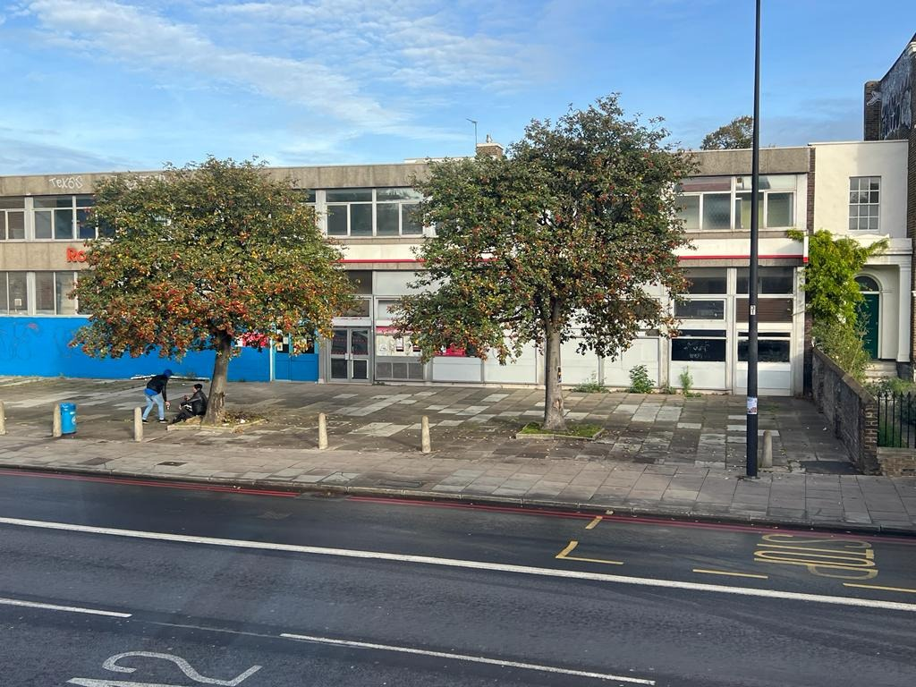

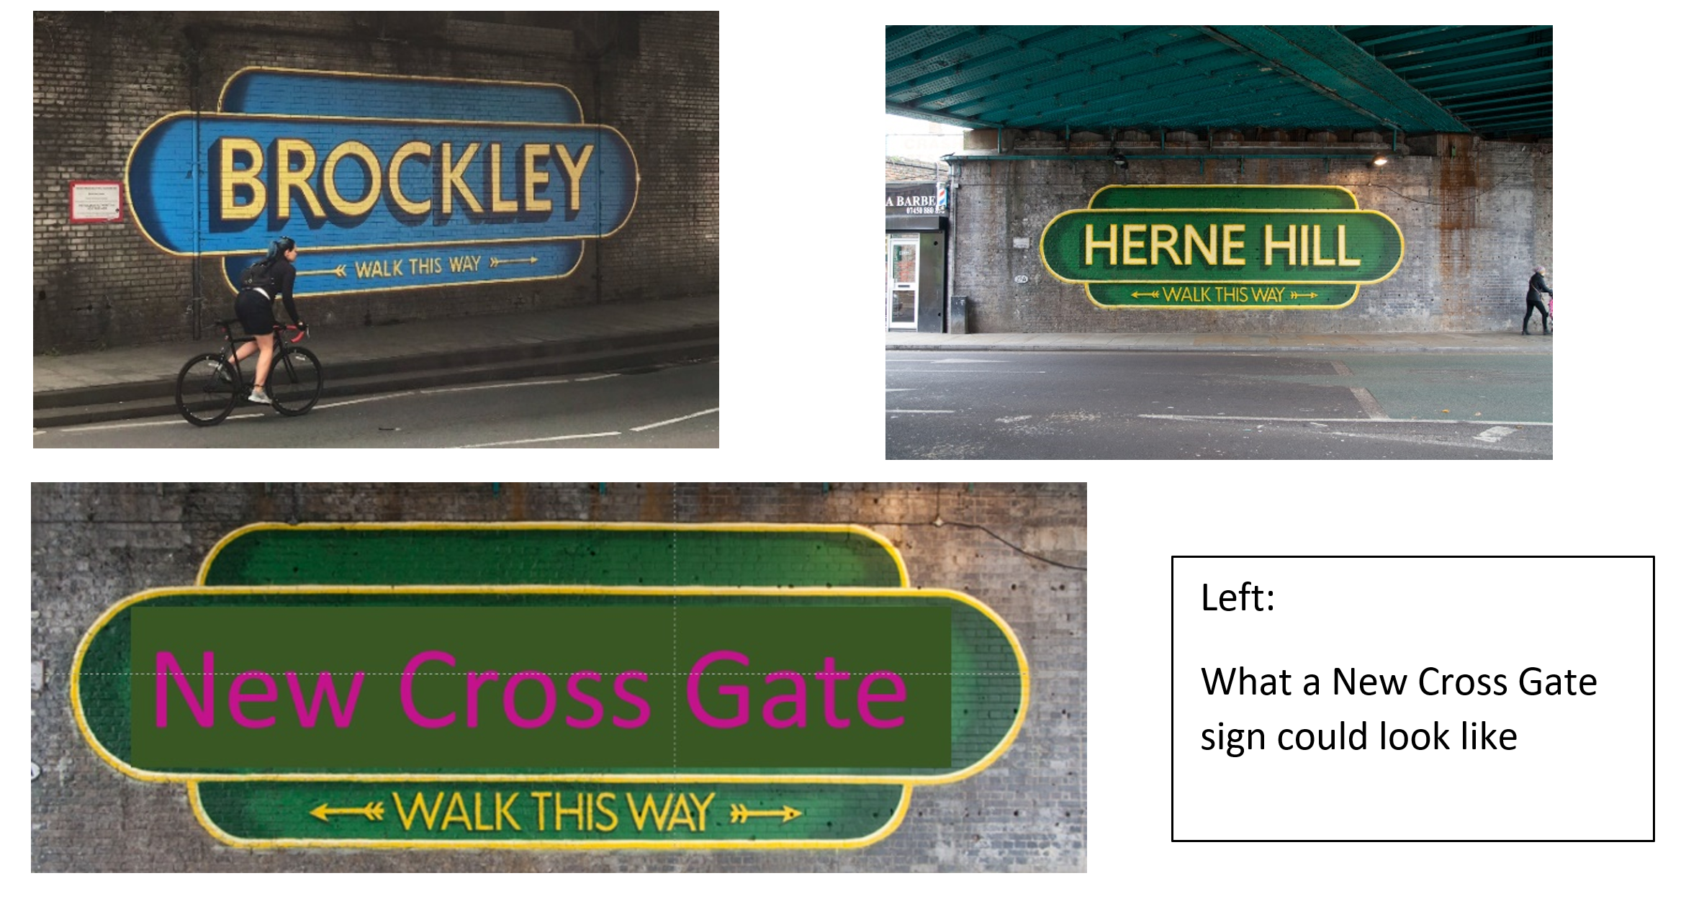
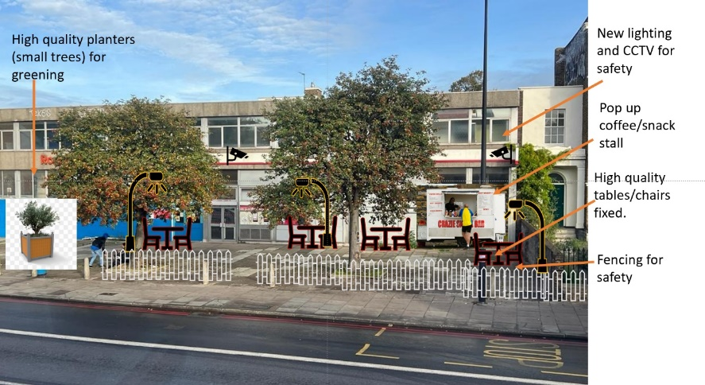
We would also want to prioritising events which inspire people to act on Climate Crisis. This includes us re-greening this space and signposting how less cars mean less toxic fumes!

We would co-design square with local artists starting with a light show and projections for Christmas (if we are awarded a CEZ ‘Creative happenings’ grant (applied for). During the borough of culture we would:
Work with local food traders (including the South American market stall holders in the near by arcade) to have a weekend festival of food in the space (in the spring). Isn’t food a creative art !! ?
Seek permission to install 3 small treader ‘boxes’ – mini box park booths for form which we can get local business to serve passing customers (3 bus stops right next to this site). We would also install safe storage for outside events, better lighting, CCTV, and power outlets. Central to the vision here would be re-greening the space to offset the dreadful carbon minoxide which is ommitted from some 10,000 journeys a day on this road.
We would involve local artists to create a wonderful historic mural showing the original GATE house which was positioned on this junction up until 1860. This would preserve the history and also link the 2 areas of our community (which are carved in two by this road).
We would consult closely with neighbours – especially business neigbours. This is not about ‘gentrification’ brining outside expenseive stall holders and trendy offerings, this is about supporting our own businesses and local people. Especially youth enterprises

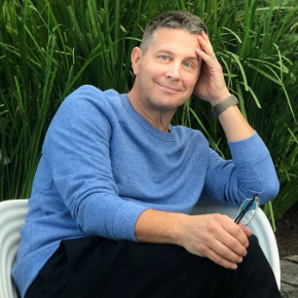
ABOUT STEPHEN CARRICK-DAVIES
Stephen set up Facework www.face.work to help empower young people to thrive in a changing world of work. Currently the organisation provides a range of online and offline training programmes including developing a chapter in India (where Stephen was born). Facework as a registered Community Interest Company is responsible for the governance and professional running of the Hatcham House project.
Stephen is an alumni of Goldsmiths’ College where he left with an honour’s degree in communication and education in 1985. Since then, he has lived in the local area and been involved in a range of social and community projects, including leading on fundraising and building the Hill Station Community Café, supporting the growth of the Telegraph Hill Festival, and has been a governor of local primary school and member of the Church Local Parish Council. Stephen is a fellow of the School for Social Entrepreneurs.
In 2020 he was able to negotiate the usage of the Hatcham Liberal Club Hall into a community workspace. Despite Covid this programme has grown and today Facework offers affordable workspace to some 180 local people who book and pay for space at HH through the HH app. During the first year Facework was able to establish positive partnerships with Lewisham council, Hyde Housing, Lewisham Homes and a range of local businesses. It is this experience and commitment to the area which Stephen would bring to this project. Currently Facework employs 2 staff and has over 15 volunteers who are committed to developing the ethos of the community social enterprise.
The HH App has revolutionised the way we engage with members including cost savings and ease of bookings.
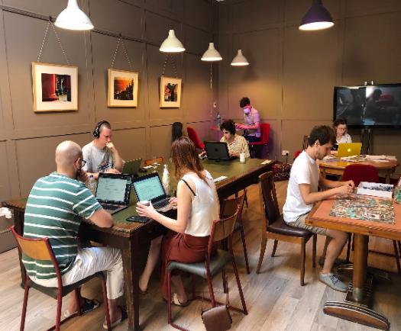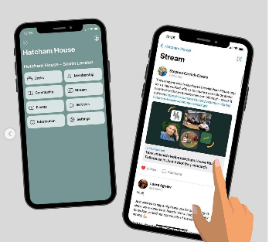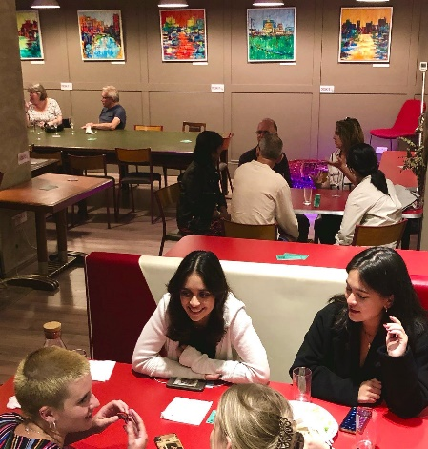

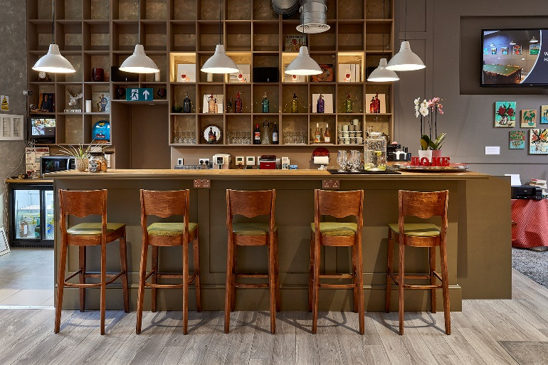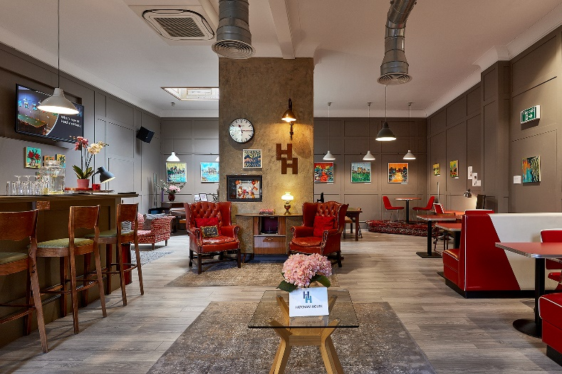

Everything we do at Hatcham House is about execllence. We may be voluntary but we are not amateur. We would bring this same commitment to quality management, inclusion and hospitality to this project whilst at the same time developing a lean, creative and fun space. Local people deserve the best. This project will be a case study on how people are empowered to lead from the grass-roots up. See www.hatchamhouse.com

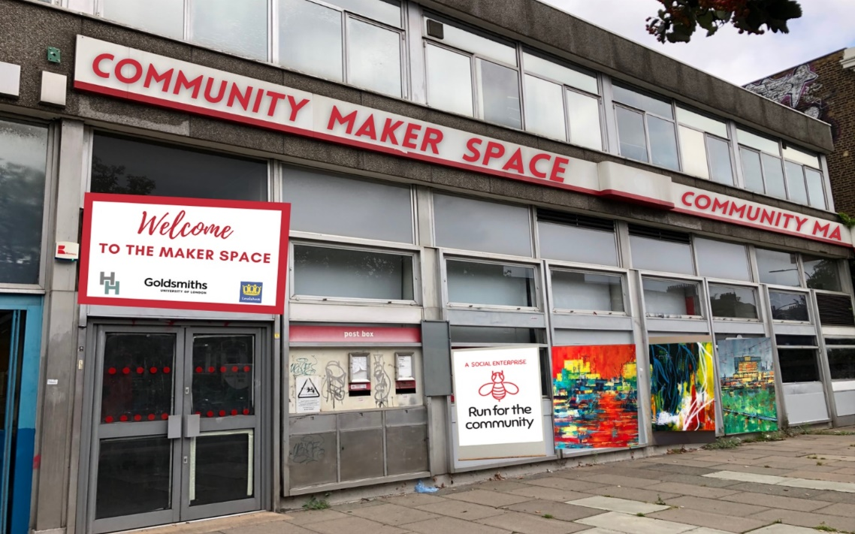

For Iillustrative purposes only. Displaying local artists work on an external galery would bring interest and use to a otherwise derilict building which is attracting grafiti on a weekly basis despite the Royal Mail building being repainted!

The following statements have been sent by representatives from the London Borough of Lewisham and Goldsmiths College London in support of the proposal from Stephen Carrick-Davies for meanwhile use of a Maker space in New Cross, South London.
“As a local authority we are very much in favour of supporting this initiative which we would support initially on a 2 year meanwhile use basis. We are already working with Stephen and his team at Hatcham House and believe that the professional standards and his grass-roots service that Hatcham House provides could be extended to this building and help to regenerate this part of New Cross, creating a real buzz and stopping the building from falling into further disrepair. The 2-year pilot could provide valuable learning for us all in how such a space is used and managed, and how this could potentially support the longer term future of the building and others like it.”
John Bennett. Head of Economy, Jobs and Partnerships Lewisham Council
“Because this building is on the gateway to the Creative Enterprise Zone we believe that it could serve as an excellent demonstrator pilot for community enterprise and learning. Combing a social space and learning space and opening it up for the public for a 2-year pilot could really help us connect with local people, bring our community together and provide much needed creative maker space facilities. We would be keen to work with Stephen and the Hatcham House team in developing this programme”.
Karen Fiagbe MAPM Economy, Jobs and Partnerships Lewisham Council
“Goldsmiths is excited about the opportunity to be part of this initiative, bringing our experience of running business support programmes and courses to help support a community based in New Cross Gate. We are already working with the Facework Group at Hatcham House and believe that by collaborating with them and Lewisham Council we could create a space that helps with our mission of supporting local entrepreneurs and engaging local communities.”
Anthony Crowther Manager NX Hub Goldsmiths.
“This project makes sense. It is the right thing to do. We are not asking for the long-term use of the space, just time to help our community get back on its feet after COVID. We are Stakeholders in what the Post Office stands for, we want social renewal, not just economic and commercial growth. This is what we will bring this to this project and if not us – who, if not now, when ? The arts and community engagement is what will bring our highstreet back. We look forward to working with the Royal Mail Group.”
Stephen Carrick-Davies CEO of Facework and founder of Hatcham House
For more information contact Stephen@hatchamhouse.com Mobile 771245 1859 see www.hatchamhouse.com and www.facework.online

See https://www.iamlewisham.uk/about This project would create a show-case model for how the arts can regenerate an area.
See www.facework.online Facework Group CIC is registerd with Companies House number 12598896
See www.hatchamhouse.com – what has made this project work is a combination of quality hospitality, flexible booking (via an app) and affordability with concession fees for students and unwaged.
Goldsmiths are actively engaged in the community and this meanwhile concept could act as a testbed for potential future aspirations in their work in the community.
“Post Offices will, even more than now, be anchors on the high street, acting as a catalyst for improved local economic performance and wider social benefit:” Nick Read, CEO POST OFFICE: FUTURE, PAST AND PRESENT PAPER https://corporate.postoffice.co.uk/media/48626/nick-read-post-office-future-past-and-present.pdf

